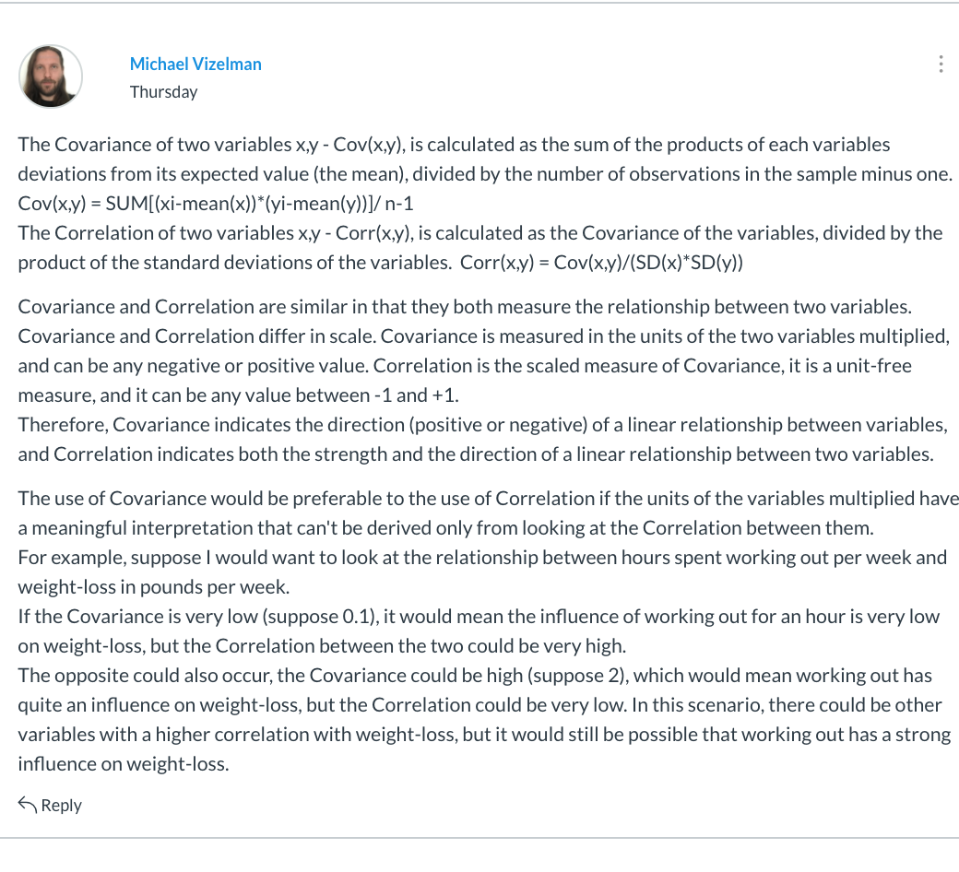

Reply:

Hi Micheal, I agree with what you said here, and also agree that there is nothing can be compare for correlation and Covariance, since they are totally different measurements with different range and meaning.

Also, the scenario you gave here is very clear to show the difference between these two indicators. However I think in this case usually time spend on working out should have a positive relationship with weight loss, so the correlation here couldn’t be negative, as our common sence.